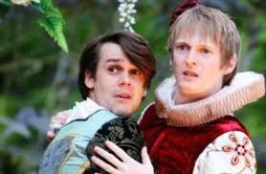
Join The Lord Chamberlain’s Men this summer, in their 21st anniversary year, for Shakespeare’s best-loved romantic comedy, Twelfth Night. With a history stretching back to William Shakespeare’s original company, they present this joyous play as he first saw it – in the open air, with an all male cast and Elizabethan costumes, music and dance.
“If music be the food of love play on!”
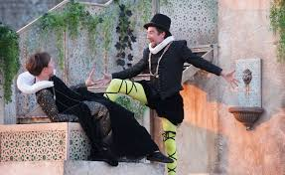
With identical twins separated by shipwreck, a cross-dressing heroine and everyone in search of love, Twelfth Night is one of the funniest and most famous tangled love stories in literature.
“O time, thou must untangle this, not I.
It is too hard a knot for me to untie.”
Bring a chair and a picnic and prepare to be entertained and transported. Book early to avoid missing out!

Lord Chamberlain’s men present Twelfth Night
At Pentille
Date & cost to be advised

